HCI Assignment #2

Airport Security Checklines

Prepared by:

Ata jalal, ahmed jalal, zhir qader

2017

1. Heuristics Evaluation
   1. During our evaluation, we assigned Ata as the facilitator, Ahmed as the computer, and Zhir as the evaluator. We used Google forms as a sheet for the evaluator to use for Nielsen’s Heuristics. The statistics of the evaluation are provided below.

Security Machine

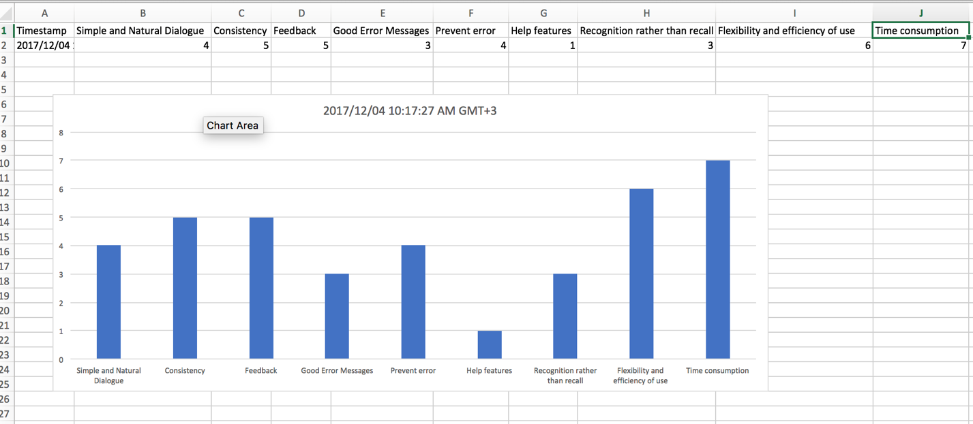

Ticket Machine

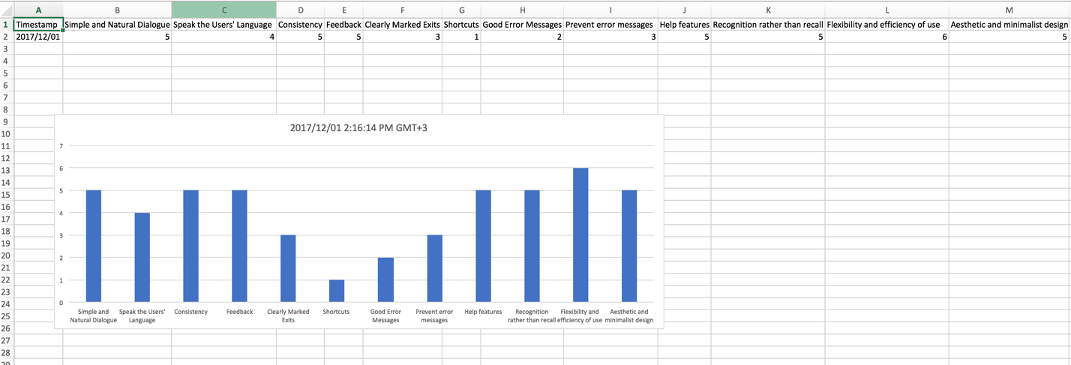

The problems that the evaluator (Zhir) wrote down are the followings.

1. For the security machine:
   1. I found that the security machine prototype lacked any help features, so if a security guard faces a problem there is no help feature to guide them through the troubleshooting.
   2. Another point is the lack of good error message, the messages only show up at certain places while during a troubleshooting, you do not see any messages.
   3. The complexity of the screen and its outputs make it hard to be recognition machine and more of a recall and memorize machine. What I mean by this is that a security guard needs to memorize the steps of dealing with the screen rather than recognizing the features easily.
2. Ticket Machine
   1. The very first problem I found with the prototype was the lack of shortcuts. The machine has no shortcut features that will assist a traveler that is in a hurry to get his/her tickets fast. Instead, the have to go through every single step which is time consuming for someone who is late.
   2. Another problem is the lack of good error messages, these messages are not to be found anywhere except at the very end of the steps in which a person gets a ticket, and in turn they have to start all over again because no error messages showed up when the person made a mistake.
   3. The screen has exit buttons in a very vague place where the user has to search for it until they find it, and that creates confusion when the user wants to exit.
   4. Although there are a variety of languages for user to choose from, there is an obvious lack of language selections and the range of the language is very limited.

1.2 The major problems we recognized due to the heuristic evaluation are the lack of good error messages in both prototypes. Also, there is the problem of the design of both screens, where the security machine screen had a very complex nature and the ticket machine screen had a vague exit button. To solve these issues, we have decided to insert error messages through out the process of using both machines. Also, we will insert help features for the security machines to guide security guards though any trouble shooting. The heuristic evaluation is useful for the detailed parts of a prototype however it is not useful as a general evaluation because you can not decide if a product is designed well overall when you evaluated and there is lack of features that make the design weak in some aspects and strong in others.

2.1 Skelton and a plan

* List of concrete changes of the security machine prototype:
  + What worked?
    - Adding help features.
    - Having error messages through out the process of using the machine
  + What did not work?
    - Making the screen less complex.
      * The screen cannot be any less complex because it has to show all the requirements and readings from the walk in machine.
* List of concrete changes of the ticket machine prototype:
  + What worked?
    - Changing the place of the exit button to be in a more visible place.
    - Adding error messages so that when a user makes a mistake, the machine will notify them and the user will have to fix their error.
  + What did not work?
    - Adding shortcuts is not suitable for this machine because you have to go through each step.
    - There are over 10 languages installed in the machine and adding more will slow down the machine because of the memory consumption of each language.

2.2 Development

**Ticket Machine:**

* Requirements
  1. Suitable space for the machine: A space should be provided to install the machines where people can easily access the machines (Estimated duration) one to two days.
  2. The machine itself: manufacturing the machine from China after sending factories the proper design (Estimated duration) three-month maximum.
  3. Software to download on each machine: Obtaining required software from META group (Estimated time three to four weeks).
  4. Paper and printer for printing the tickets: This should be a build-in feature in side the machine.
  5. Hanging screens to show ticket numbers: Buying screens from Samsung to show the ticket numbers (Estimated time maximum one week).
* Task Groups
  1. Basic design will include all the requirements provided above.
  2. Stretch goal: We are aiming to aggregate the ticket machines according to age.

**Security Machine:**

* Requirements:
  1. Suitable space for the machine: Removing the old security machines and adding the new ones. (Estimated time one Week).
  2. The machine itself: manufacturing the machine from America. The design should include a screen that reads input and is connected to the machine (Estimated time six months).
  3. Software to download on each machine: Obtaining required software from a security company (Estimated time six months).
  4. Required cabling for necessary connections.
  5. A security guard: Keeping eyes on the machine and the screen and acting according to the output from the machine.
* Task Group:
  1. Basic design will include all the requirements provided above.
  2. Stretch goal: The screen will be interactive and smart and once the machine detects something abnormal, it will block the user pass through he machines.

3) Meat on the bones

Pictures for the security machine prototype in detail:

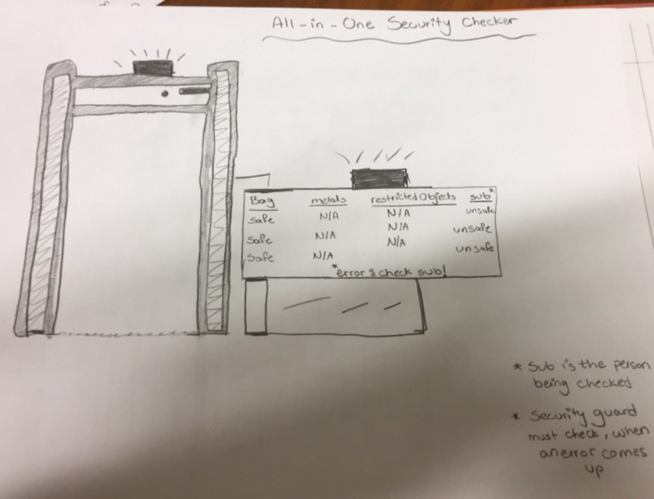

Figure 1 an overview of the security machine as a whole

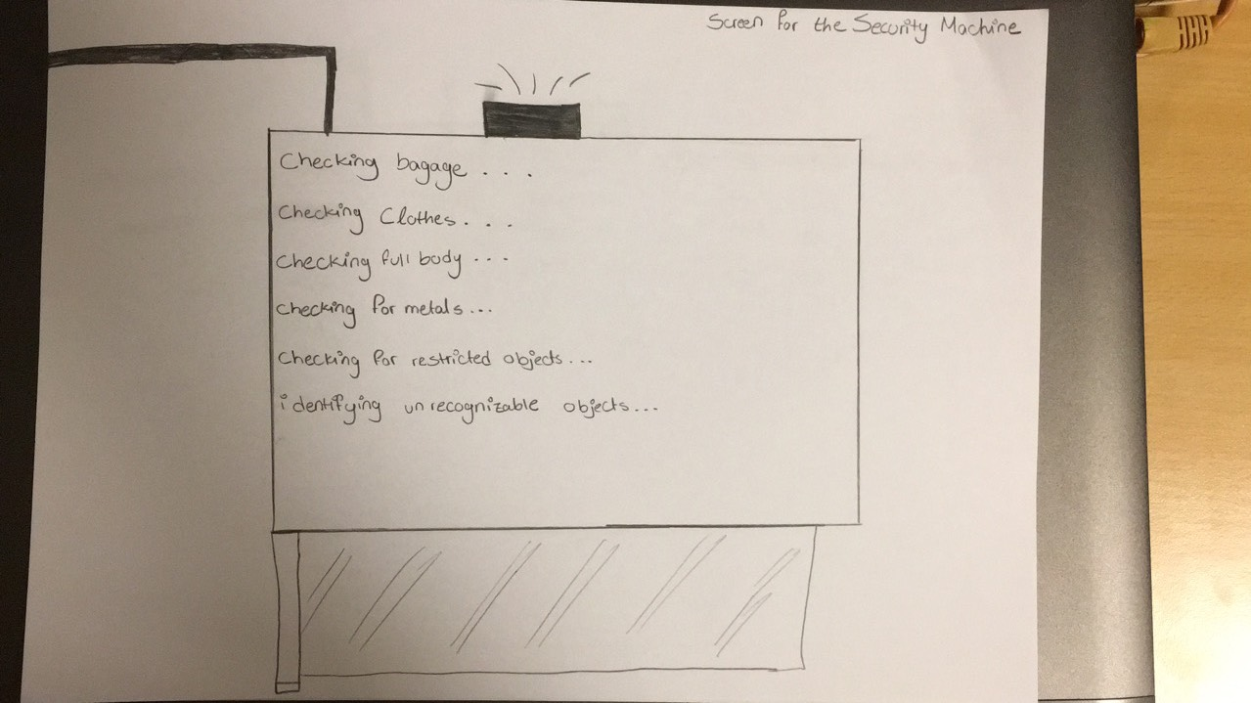

Figure 2 a close up picture of the screen during initial testing

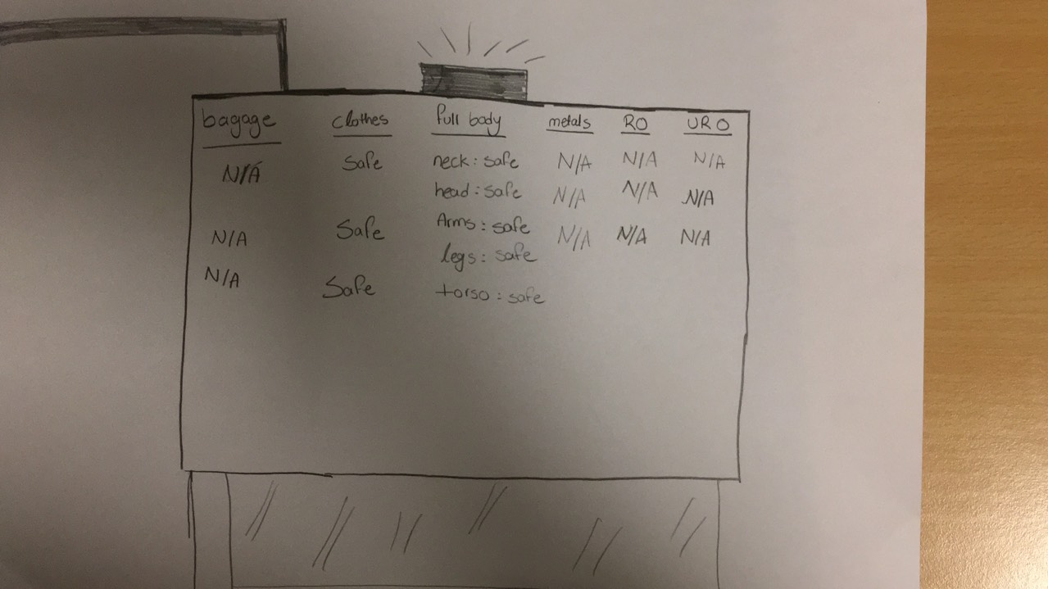

Figure 3 a close up picture of the screen after the chechking

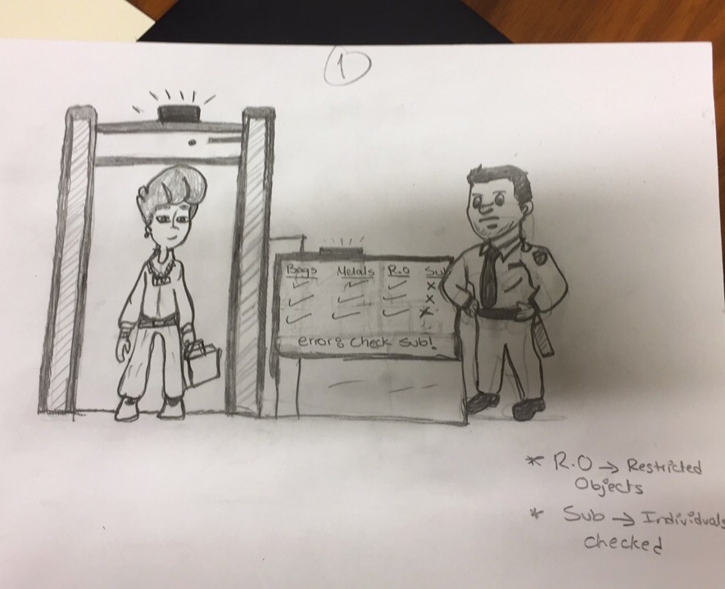

Figure 4 a comic illustration of the security machine when the user is present

Pictures for the security machine prototype in detail:

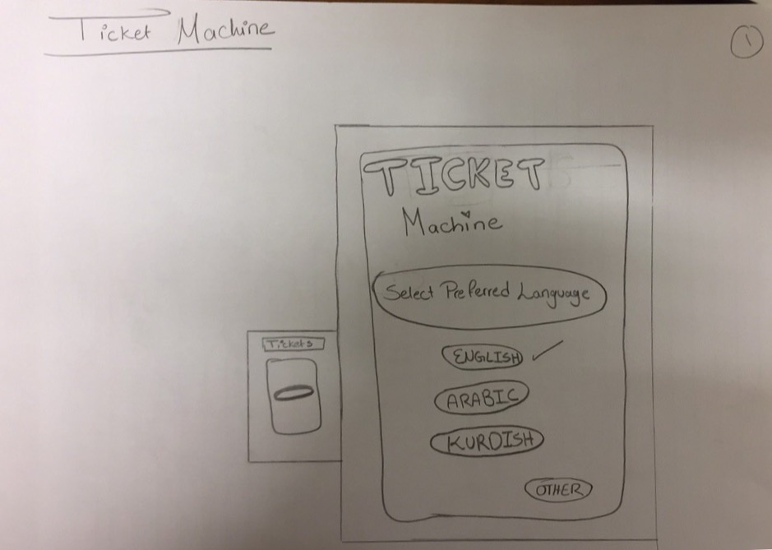

Figure 5 a close up of the ticket machine for selecting the language

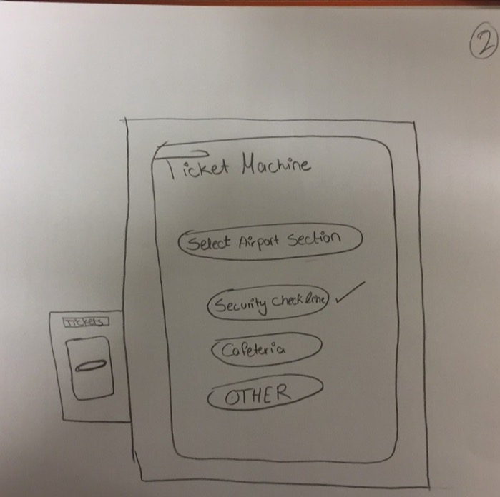

Figure 6 choosing which section the ticket is for

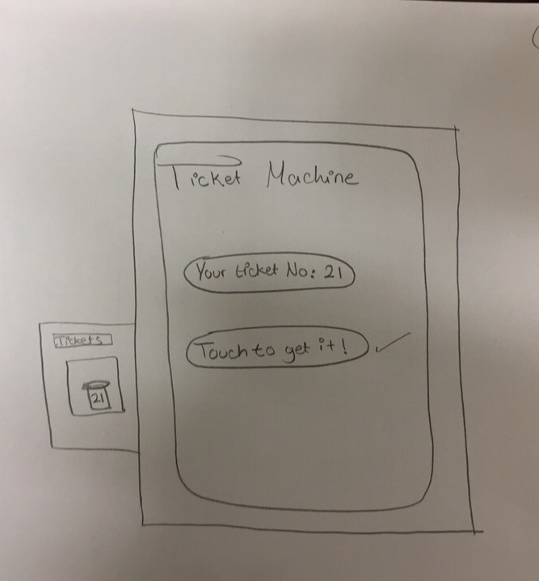

Figure 7 final step to print your ticket from the machine

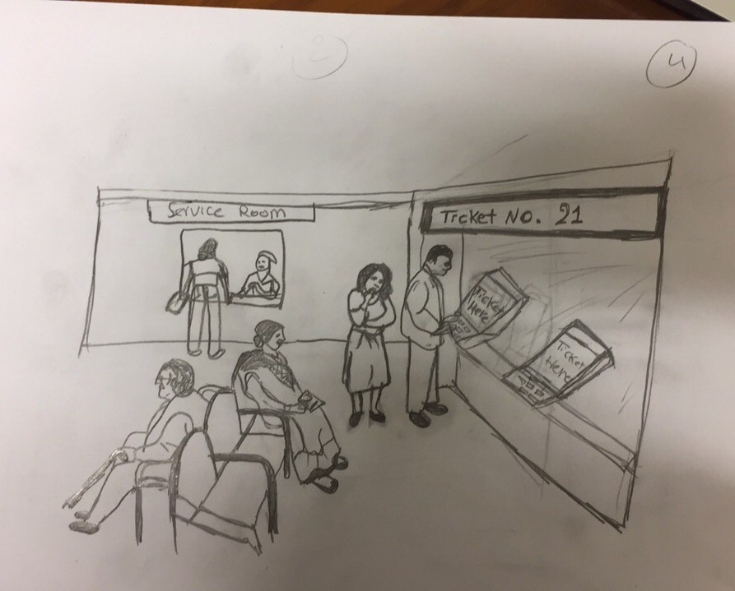

Figure 8 a comic illustration of the ticket machine used in airports